
Welshmoor Rules are Regulations
We aim to run a fun and safe show for all abilities, please read and follow the rules so that everyone can have an enjoyable time
- Stallions may be handled by juniors if they are suitable to do so
- No horse under 4 to be ridden unless stated
- We allow tiny tots in our fun/ Have A go classes, in open classes please make sure riders have obtained their 3rd birthday.
- Pleased keep dogs on a lead and in a controlled manner, Same goes for children apart from the lead (unless you feel they would be better on a lead)
- Please clear up your litter and droppings, keep the show ground clean and tidy.
- Judges give up their time to attend our shows, their decision is final. No abuse at any officials will be tolerated.
- No schooling whips in the ring please
- Any excessive use of whips or spurs on a horse will result in the competitor being asked to leave the ring.
- Please attempt to always keep all horses and ponies under control. Just do your best
- There will be NO class swapping of any kind.
- Refunds will not be given, class vouchers may be offered instead
- Please refrain from taking screen shots of the official photos. Anyone caught doing this who has not paid for said photo, will be restricted from entering any future Welshmoor Event shows.
- Classes will not start before stated on the schedule
- We cannot predict class times, Due to taking entries on the day, we advise you watch your ring accordingly. We are not responsible should you miss your class or classes clashing, You can enter very last minute at our shows so if you find you can make a class and you are not entered, you can simply enter!
- Flu vaccinations are required and need to be checked before unloading, No passport, No entry. Initial course/booster + 7 days needed for all equines on the premises

RING ONE – INDOOR ARENA
STARTING AT 9am
Judge: Mrs C Whiteley

- BEST TURNED OUT. Open to in hand and ridden competitors
- FAMILY HORSE/PONY. 4yr +. Animal to be suitable to be ridden by all family members, to be ridden in a snaffle
- IN HAND UNREGISTERED. Any age, any breed. Open to animals assumed to be of their breed, but unregistered with their society
- IN HAND BEST CONDITION HORSE OR PONY. Any age, type and breed. Open to grass and stable kept
- IN HAND VETERAN HORSE OR PONY. 15 years and over
Championship for 1st and 2nd prize winners from classes 1 - 5

- IN HAND ARAB, PARTBRED AND ANGLO, Any Age
- IN HAND THOROUGHBRED AND PART BRED, Any Age
- IN HAND RIDING PONY, SHOW PONY & SHOW HUNTER PONY, Any Age
- IN HAND HACK, HUNTER & RIDING HORSE, Any Age
Championship for 1st and 2nd prize winners from classes 6 - 9

LUNCH BREAK

CLASSES TO RECOMMENCE NOT BEFORE 12.30
10. IN HAND MOUNTAIN & MOORLAND ADULT LARGE BREED, 4yrs +
11. IN HAND MOUNTAIN AND MOORLAND ADULT SMALL BREED 4yrs +
12. IN HAND MOUNTAIN AND MOORLAND YOUNGSTOCK, 3yrs and under
Championship for 1st and 2nd prize winners from classes 10 – 12

13. RIDDEN PIEBALD & SKEWBALD, 4yr +, open to all suitable types
14. RIDDEN ROAN, PALAMINO, SPOTTED & DUN, 4yr + open to all suitable breeds and type
15. RIDDEN COB & COB TYPE, 4yr + Open to all suitable types
16. RIDDEN VETERAN HORSE OR PONY, 15 years and over
Championship for 1st and 2nd prize winners from classes 13 - 16

17. LEAD REIN SHOW PONY & SHOW HUNTER PONY, 4 yrs +, Rider to be 3years old but not to have obtained their 9th birthday, to be ridden in a snaffle
18. FIRST RIDDEN SHOW PONY & SHOW HUNTER PONY, 4yrs +, Rider not to have obtained their 12th birthday, to be ridden in a snaffle
19. OPEN JUNIOR RIDDEN, 4yrs +, open to all breeds and types. Riders to be 18 or under. This class is not open to lead rein or first ridden
Championship for 1st and 2nd prize winners from classes 17 - 19

20. LONGEST MANE AND TAIL
21. PRETTIEST MARE
22. HANDSOMEST GELDING
23. BEST KEPT FEET
24. NICEST EYES
25. HORSE/PONY JUDGE WOULD LIKE TO TAKE HOME
26. HORSE/PONY THAT MOST LOOKS LIKE THEIR OWNER
27. FANCY DRESS

RING TWO – OUTDOOR ARENA
STARTING AT 9am
Judge; Mrs W Toomer-Harlow

28. RIDDEN UTILITY HORSE OR PONY TYPE, 4yrs and over, Animal to have allrounder ability, Able to undertake multiple disciplines
29. RIDDEN COMPETITION TYPE , 4yrs and over, Eventer, Dressage, Show Jumping Type
30. CHILD HANDLER, Any age, Handler to be under 18 yrs old
31. ADULT HANDLER, Any Age. Hander to be over the age of 18 years old
Championship for 1st and 2nd prize winners from classes 28 - 31

32. BROODMARE WITH OR WITHOUT FOAL AT FOOT (COVERING CERTIFICATE NEED FOR NO FOAL ATTENDANCE), Any type or breed
33.. RIDDEN JUNIOR EQUITATION, 4yrs over, Rider under 18yrs old. Conformation and blemishes will not be taken into account. To be judge on riders ability with their animals, to be suitably bitted
34. RIDDEN SENIOR EQUITATION, 4yrs over, Rider over 18yrs old. Conformation and blemishes will not be taken into account. To be judge on riders ability with their animals
35. RIDDEN UNREGISTERED, 4yrs and over, Open to animals assumed to be of their breed, but unregistered with their society
Championship for 1st and 2nd prize winners from classes 32 - 35

LUNCH BREAK
CLASSES TO RECOMMENCE NOT BEFORE 12.30
36. RIDDEN ARAB, PARTBRED AND ANGLO, 4yrs +
37. RIDDEN THOROUGHBRED AND PART BRED, 4yrs +
38. RIDDEN RIDING PONY, SHOW PONY & SHOW HUNTER PONY, 4yrs +
39. RIDDEN HACK, HUNTER & RIDING HORSE, 4yrs +
Championship for 1st and 2nd prize winners from classes 36 - 39

40. RIDDEN MOUNTAIN & MOORLAND LARGE BREED, 4yrs and Over
- RIDDEN MOUNTAIN & MOORLAND SMALL BREED, 4 years and Over
42.FIRST RIDDEN MOUNTAIN & MOORLAND, 4 years and over, Rider to be 3 years old but not to have obtained their 12th birthday, to be ridden in a snaffle
43.LEAD REIN MOUNTAIN & MOORLAND, 4 years and over, Rider to be 3 years old but not to have obtained their 9th birthday, to be ridden in a snaffle
Championship for 1st and 2nd prize winners from classes 40 - 43

44. IN HAND PURE BRED, All ages and breeds
45. IN HAND HEAVY HORSE AND PART BRED, All ages
46. IN HAND DRIVING HORSE OR PONY OR OF DRIVING TYPE, 4 years and over, may be shown in Harness
47. RIDDEN PURE BRED, 4 years + All breeds
48. RIDDEN HEAVY HORSE AND PART BRED. 4yrs plus
Championship for 1st and 2nd prize winners from classes 44 - 48

49. IN HAND PIEBALD & SKEWBALD, All ages, Open to all suitable types
50. IN HAND ROAN, PALAMINO, SPOTTED & DUN, All ages, Open to all suitable types
51. IN HAND OPEN YOUNGSTOCK, Age 3 and under, Open to all breeds and types
52. IN HAND COB & COB TYPE, 4yrs and over, Open to all suitable types
Championship for 1st and 2nd prize winners from classes 49 - 52

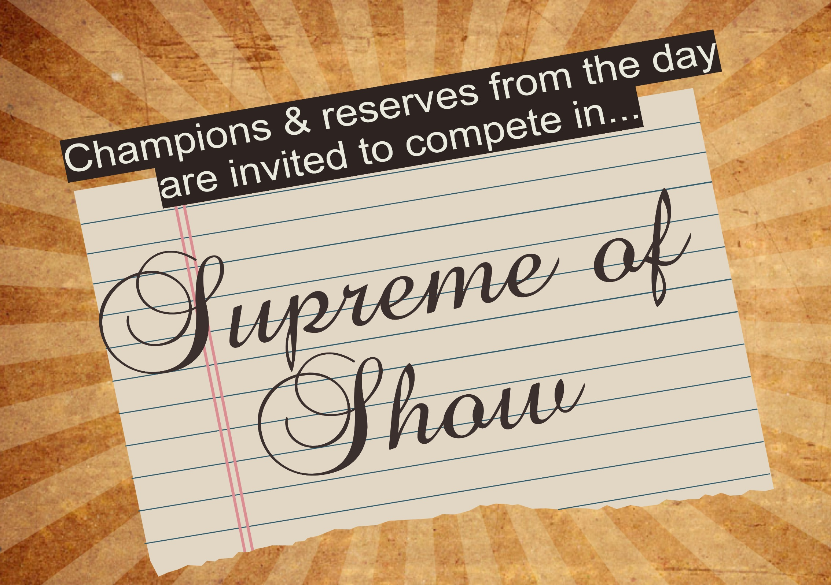
WELSHMOOR ENTRY FORM
An entry form must be filled in for competing. You do not need a competitor number if you are only entering the fun classes, but you will need to complete the form

CLASS NO | HORSE/PONY | RIDER | CLASS FEE | OFFICIALS ONLY
 |  | Total Fee

EMAIL ADDRESS…………………………………………………………………………………………………….
CONTACT NUMBER………………………………………………………………………………………………………
SIGN TO AGREE TO RULES AND REGULATIONS OF THE SHOW ………………………………………………………………………………………………………………………………..
Thank you so much for supporting Welshmoor Events today!

