
Pre - Entries Close: 21st October – Entries Taken on the Day
https://welshmoorevents.lite.events/
Open Welshmoor classes: £13 pre-entry and £15 on the day. Card, cash or PayPal on the day
Fun Classes tickets: £5. On the day entry only (5 classes for £20)
Pre enter and enter more on the day for pre-entry rates.
Welshmoor Rules are Regulations
We aim to run a fun and safe show for all abilities, please read and follow the rules so that everyone can have an enjoyable time
- Stallions may be handled by juniors if they are suitable to do so
- No horse under 4 to be ridden unless stated
- We allow tiny tots in our fun classes, in open classes please make sure riders have obtained their 3rd birthday.
- Pleased keep dogs on a lead and in a controlled manner, Same goes for children apart from the lead (unless you feel they would be better on a lead)
- Please clear up your litter and droppings, keep the show ground clean and tidy.
- Judges give up their time to attend our shows, their decision is final. No abuse at any officials will be tolerated.
- No schooling whips in the ring please
- Any excessive use of whips or spurs on a horse will result in the competitor being asked to leave the ring.
- Please attempt to always keep all horses and ponies under control. Just do your best
- There will be NO class swapping of any kind.
- Refunds will not be given, class vouchers may be offered instead
- Please refrain from taking screen shots of the official photos. Anyone caught doing this who has not paid for said photo, will be restricted from entering any future Welshmoor Event shows.
- Classes will not start before stated on the schedule
- We cannot predict class times, Due to taking entries on the day, we advise you watch your ring accordingly. We are not responsible should you miss your class
- Should a competitor have any link to a judge (or visa versa) in the current or previous year of the show by means of, producing, selling, loan or lease of an animal, showing of an animal (free or for a fee), teaching, sponsorship or brand ambassador, they will not be permitted to judge, or be judged at Welshmoor Event shows by those persons. A judge may also not judge an animal they have bred. Should this rule found to be broken you will be withdrawn. Judges are permitted to refuse to judge any persons they feel have contravened this ruling.
In Hand Classes Indoor Arena
Judge – Mrs K Hawes

Ring to start at 9am
- In Hand Novice Pony/horse. Not to have won more than two 1st prizes in any in hand showing before the 1st Jan in the current year. This class is open to all breeds and types.
- In hand Veteran. 15 yrs + open to all breeds.
- In Hand Gelding. Any Age, Any Type
- In Hand Mare, Any Age, Any Type
- Para Handler. Any Age, Any Type, Competitors to have physical and non-physical disabilities

In hand ‘Ghost’ championship 1st and 2nd prize winners from classes 1 to 5

- In Hand Foal. any type, may be shown with or without their dam
- In Hand Yearling, Any Type
- In Hand 2 yr Old., Any Type
- In Hand 3 yr old. Any Type
In Hand Youngstock Championship 1st and 2nd prize winners from classes 6 – 9
- Mountain & Moorland: Open to In Hand Mountain & Moorland ponies of ANY AGE registered with their respective Pure Bred societies Of Welsh A, B, C and D, Dartmoor, Exmoor, Shetland, Fell, Dales, Highland, New Forest, Connemara. Stallion, Mare, Colt, Filly or Gelding
- In hand Coloured and Odd Coloured. Piebald, skewbald, Palominos, Duns, Roans, paints, and spots. Open to Horses and ponies of all ages. And all types
- In Hand Black, Bays, Greys & Chestnut. of any age and height
- In hand Driving Type, Any age, height and type
- Open In Hand, Any age, height & Type

In hand ‘Pumpkin’ championship 1st and 2nd prize winners from classes 10 – 14

Lunch Break
Indoor arena may be used for warming up before the ridden classes.

Ridden Classes Indoor Arena
Mr Carnegie will join Mrs Hawes to probation

Not Before 12.30

- Novice Ridden Horse and Pony. Open to Horses and ponies of 4 yrs. and over. Not to have won more than two 1 st prizes in any Ridden showing before the 1st of Jan in the current year
- Lead rein and first ridden. Open to all breeds. First ridden riders 12 years old and under. To be shown in any suitable bridle. Lead to be attached to the noseband. Lead rein riders 9 years old and under. Class will be split if entries warrant.
- Walk and Trot. Open to Horses and Ponies of 3 years and over. Open to lead rein and first ridden
- Para Rider. Any Age, Any Type, Competitors to have physical and non-physical disabilities

‘Vampire’ Ridden class championship. 1st and 2nd prize winners from classes 15-18

- OPEN RIDDEN MOUNTAIN & MOORLAND BREEDS. Open to Mountain & Moorland ponies registered with their respective Pure-Bred Societies of, Welsh, A, B, C and D, Exmoor, Dartmoor and Shetland, Highland, Fells, Dales, New Forest. Stallion, mare or gelding, 4 years old and over. Rider any age. Lead Rein permitted. Class may be split if entries warrant.
- Ridden Coloured and Odd Coloured Horse and Pony. Including Piebald, Skewbald, Duns, Palominos, Roans. Lead rein permitted in this class.
- Ridden Bay, Black, Grey and Chestnut. Open to horses and ponies 4 years and over, any height, type, lead rein permitted
- Veteran ridden. 15+ years. Open to all breeds including lead rein
- Open Ridden. Horse and Ponys over 4 years old. Lead rein permitted.

Wicked Witch’ Ridden class championship. 1st and 2nd prize winners from classes 19-23
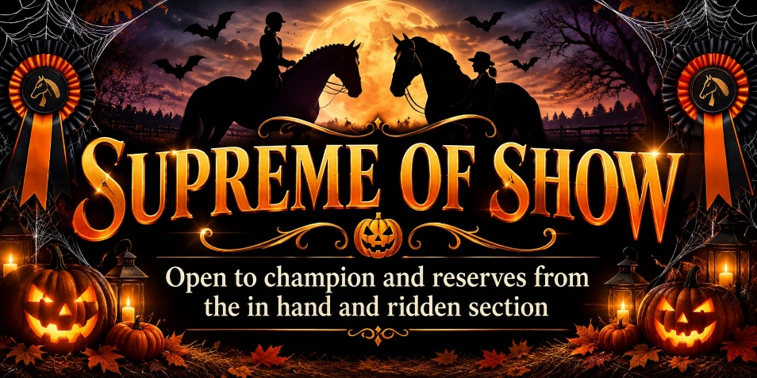

Fun Class Ring
Ring 2 -Outdoor Arena
Judge – Mr J Carnegie

Ring to Start at 9am.
24 | Best Turned Out Ridden or In hand | 32 |  | Cutest Pair
25 | Novice Rider | 33 |  | Mums & Dads Class (Mums and Dads welcome to bring the pony in, no show wear required)
26 | Young Handler (Under 16) |  | 34 | Prettiest Mare
27 | Best Up Downs | 35 |  | Handsomest Gelding
28 | Tiny Tots Ridden | 36 |  | My first class off the lead,- Trotting not required if unable, grooms can stand in the centre.
29 | Best Decorated Mane and Tail | 37 |  | Pony the judge would like to take home
30 | Best Bottom | 38 |  | Fancy Dress
31 | My Best Friend
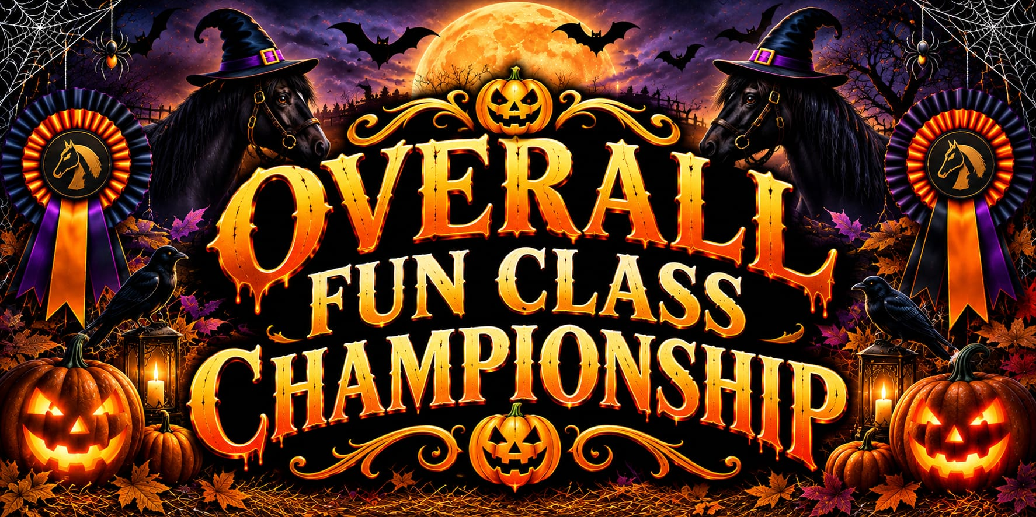

Open to 1st & 2nd from classes 24 – 38

Fun Class Tickets - £5 each or 5 for £20
Welshmoor Events run a ticket method for the fun classes, Simply purchase as many tickets as you wish and hand them in as you go in the ring. No competitor numbers are needed for the fun ring

WELSHMOOR ENTRY FORM
An entry form must be filled in for EACH horse or pony that is competing. You do not need a competitor number if you are only entering the fun classes, but you will need to complete the form
CLASS NUMBER | ENTRY FEE
Fun Class Tickets

TOTAL

NAME OF HORSE/PONY……….………………………………………….

EMAIL ADDRESS…………………………………………………….

CONTACT NUMBER…………………………………………………………

RIDER/HANDLER NAME,
…………………………………………………………………….

SIGN TO AGREE TO RULES AND REGULATIONS OF THE SHOW
……………………………………………………………………..

Thank you so much for supporting Welshmoor Events today!

